Abstract
This technical note introduces the Multi-Quantum Mode (MQM), a novel data transmission algorithm designed to maximize throughput by simultaneously
encoding binary data across three physical dimensions: Frequency (n bits), Amplitude (m bits), and Phase (p bits). By utilizing a 3D-mapping approach,
the MQM algorithm achieves a theoretical throughput defined by the core formula:

Data Throughput = [ ( n + m bits) x 2^p ]/cycle

This method effectively optimizes spectral efficiency by exploiting phase-superposition,
offering a robust alternative to conventional PAM-OFDM-phase architectures.

Item | Value
Conventional HBM3e  Bandwidth | ~1.2 TB/s
MQM HBM4 Theoretical  Bandwidth | ~1 PB/s ( Frequency (8 bits), Amplitude (8 bits), Phase (8 bits) )
Multiplier | ~833×
Crazy MQM | ~64 PB/s( Frequency (8 bits), Amplitude (8 bits), Phase (14 bits) )  = 2^56 bits/s ( which is theoretically comparable to  a 56–60 Qubit-scale data throughput capacity.)
"While Google's Willow required a multi-billion dollar investment to reach 105 Qubits,
MQM delivers equivalent-scale data throughput (~56–60 Qubit-capacity) by integrating
a single compact MQM encoder/decoder IP block into existing CPU and HBM architectures — no redesign required." * Intellectual Property Block : IP block
[n th CPU/GPU core ] → [MQM Encoder IP] → wire → [MQM Decoder IP] → [HBM4 or all electronics]
[HPM4 or all electronics] → [MQM Encoder IP] → wire → [MQM Decoder IP] → [ n th CPU/GPU core ]
------------------------------------------------------------------------
CPU / GPU / NPU
┌────────────────────────┐
│ ┌─────────┐ ┌─────────┐ │
│ │ Core 1 ...... │ │ Core n │ │
│ └────┬────┘ └────┬────┘ │
│ │ │ │
│ ┌────┴────┐ ┌────┴────┐ │
│ │ MQM │ │ MQM │ │
│ │ ENC/DEC │ │ ENC/DEC │ │
│ └────┬────┘ └────┬────┘ │
└──────┼───────────┼──────┘
↕ ↕
════════════╪═══════════════════╪═════
Existing wire (unchanged)
════════════╪═══════════════════╪═════
↕ ↕
┌──────┼───────────┼─────┐
│ ┌────┴────┐ ┌────┴────┐│
│ │ MQM │ │ MQM ││
│ │ ENC/DEC │ │ ENC/DEC ││
│ └────┬────┘ └────┬────┘│
│ │ │ │
│ ┌────┴────┐ ┌────┴────┐ │
│ │ HBM4 / │ │ HBM4 / │ │
│ │All Elec │ │All Elec │ │
│ └─────────┘ └─────────┘ │
└────────────────────────┘
HBM4 / All Electronics
image Files :
3-1. CPU_HBM_ALL electronics.png ( CPU / GPU / NPU <=> HBM )
3-2. CPU_HBM_ALL electronics.png ( All electronics <=> optic fiber/wire <=> all electronics )
6. MQM_ALU_Wave Compute(26.03.13)2-1.jpg ====== MQM ALU
6. MQM_ALU_Wave Compute(26.03.13)2-2.jpg ====== MQM ALU
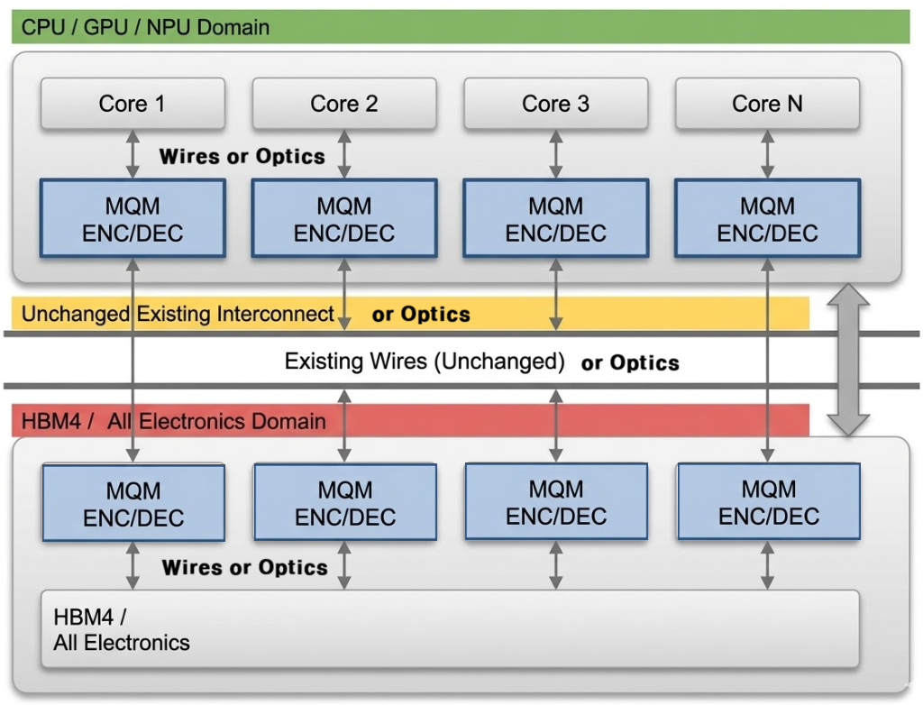
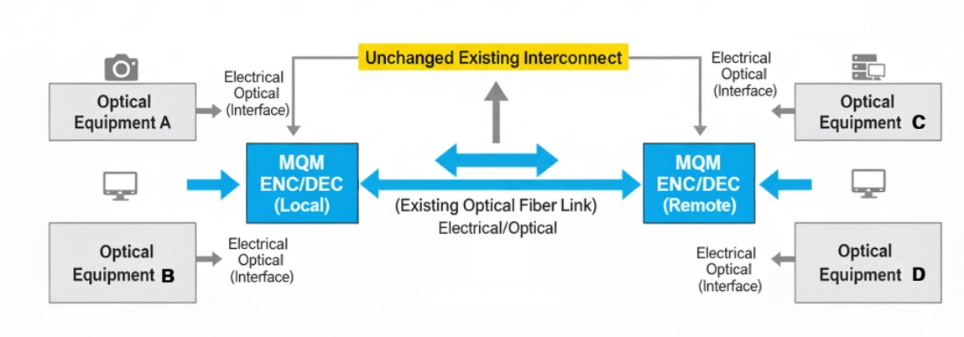
------------------------------------------------------------------------

Theoretical Framework and Throughput Specification:
The proposed MQM architecture defines each data symbol as a function of Frequency (F), Amplitude (A), and Phase (P).
The core signal transformation is expressed by the wave equation:

S(t)=Asin(2πft+ϕ)

By mapping bit-depths to each physical parameter—Amplitude (8 bits), Frequency (8 bits), and Phase state(8 bits)—the system transcends
traditional binary constraints. The data density is calculated as (8+8) x 2^8 = 4,096 bits per wire per cycle.

------------------------------------------------------------------------

▷ Data Transmission Analysis for Phase 1
The following table outlines the binary data transmission during the Phase 1 operation,
mapping the bit streams to their corresponding decimal values and ASCII interpretations.

Phase 1: Data Transmission
Mapping Table
Transmission  Component | Binary Sequence | Decimal Value | Option A  ( Freq-primary) | Option B  ( Amp-primary )
Byte 1 (MSB) | 01001001 | 73 | 73 Hz x ASF | 73 mv x ASF
Byte 2 (LSB) | 01010101 | 85 | 85 mv x SF | 85 Hz x SF
(Note: SF or ASF denotes the system-specific Scaling Factor.)

Phase 1 Transmission Protocol : (SF = ASF =1) ( binary) 01001001 01010101
- Option A (Freq-Primary): 73 Hz carrier with 85 mV modulation
=> 73 Hz on 85 mv
- Option B (Amp-Primary): 73 mV carrier with 85 Hz modulation
=> 73 mv on 85 Hz

"Practical Implementation-Ready
: This work includes precise physical-layer data conversion benchmarks (Byte 1: 73, Byte 2: 85),
allowing for direct translation from theoretical 3D-mapping models to actionable hardware protocols."

☞ Technical Implementation Notes
• Parameter Scaling: The raw decimal values (73 and 85) serve as the base digital units.
The final physical output is derived by multiplying these values with the system-specific Scaling Factor
to account for sensor sensitivity and calibration.

• Interpretation Methodology: Depending on the target sensor module, the system interprets the byte value
either in the frequency domain (Hz) for oscillation analysis or in the voltage domain (mV)
for bio-potential measurements.
•Data Integrity: Ensure that the scaling factor remains synchronized between the transmitter and the receiver
to maintain precision in signal reconstruction.

------------------------------------------------------------------------

Technical Specifications for MQM Throughput in HBM4 Interface:
This study proposes a high-density data transmission logic utilizing the HBM4 2048-wire (channel) architecture.
By integrating Frequency, Amplitude, and Phase modulation, the system achieves the following throughput:
- Modulation Parameters: Frequency (8 bits), Amplitude (8 bits), Phase (8 bits)
- Per-Wire Throughput Logic: (8 bits Frequency + 8 bits Amplitude) x 2^8 (Phase states) = 4,096 bits/cycle
- Channel Scaling:
  - 64 wires (Channels): 64 x 4,096 bits/cycle = 262,144 bits/cycle = 32 KB/cycle
  - 2048 wires (Full HBM4): 2,048 x 4,096 bits/cycle = 8,388,608 bits/cycle = 1 MB/cycle

- Performance Metrics at 1 GHz Clock Frequency:
  - 64-wire Channel: Provides 32 KB/cycle, achieving a bandwidth of 32 GB/s.
  - 2048-wire Interface: Provides 1 MB/cycle,
achieving a total bandwidth of 1 PB/s (Petabyte per second).
=> schema : MQM_final(2026.03.09).jpg, MQM_table(2026_03_09).jpg
Item | Value
Conventional HBM3e Bandwidth | ~1.2 TB/s
MQM HBM4 Theoretical Bandwidth | ~1 PB/s ( Frequency (8 bits), Amplitude (8 bits), Phase (8 bits) )
Multiplier | ~833×
Crazy MQM | ~64 PB/s( Frequency (8 bits), Amplitude (8 bits), Phase (14 bits) )  = 2^56 bits/s ( which is theoretically comparable to  a 56–60 Qubit-scale data throughput capacity.)
This architecture enables deterministic, ultra-high-speed data streaming, effectively eliminating memory bottlenecks in large-scale neural network databases.
This document is released as Prior Art (2026.03.04) to serve the research community by establishing public domain accessibility and preventing restrictive third-party patent claims. The authors waive all patent rights; this work is strictly open-source.

Author: Sungtae Park (scwpark) | scwpark@naver.com
Co-worker: Hyunuk Pak | iamgilchi@naver.com
Co-worker: EunHwan Park | dmsghks0421@gmail.com
GitHub: https://github.com/scwpark/MQM-PAM_OFDM_Phase-superposition_3D-mapping
Community: https://cafe.daum.net/scwpark
https://blog.naver.com/namyangju_first/223768176061

